Title: | Window Lifter Module  Design Specification Document

History
Issue status  (Index) | Maturity/Date  (draft/invalid/valid)  (dd-mmm-yyyy) | Author  Department | Check/Release  Department | Description
1.0 | Draft  24-0ct-17 | Jorge Acevedo | Jorge Acevedo | Filled the general information of the document, purpose, and realization constrains and Targets.
2.0 | Draft  25-Oct-17 | Jorge Acevedo | Jorge Acevedo | Conceptual design(Electric Diagram and layers’ connection)
3.0 | Draft  25-Oct-2017 | José Antonio | José Antonio | Conceptual design(Functional Diagram)
4.0 | Draft  26-Oct-2017 | José Antonio | José Antonio | Functions decomposition from the GPIO and PORTS headers at the MCAL layer
4.0 | Draft  26-Oct-2017 | Jorge Acevedo | Jorge Acevedo | SW Component Internal Breakdown (Functional Decomposition), definition, abbreviations and references.
6.0 | Draft  27-Oct-2017 | José Antonio | José Antonio | Functions decomposition from the LPIT header at the MCAL layer
7.0 | Draft  27-Oct-2017 | José Antonio | José Antonio | Functions decomposition from the InitPORT and InitClock headers at the HAL layer
8.0 | Draft  28-Oct-2017 | Jorge Acevedo | Jorge Acevedo | Functions decomposition from the ControlPin and DesableWDOG headers at the HAL layer
9.0 | Draft  28-Oct-2017 | Jorge Acevedo | Jorge Acevedo | Functions decomposition from the initLPIT at the HAL layer
10.0 | Draft  29-Oct-2017 | José Antonio | José Antonio | Functions decomposition from the ReadPin header at the HAL layer
11.0 | Draft  29-Oct-2017 | José Antonio | José Antonio | Functions decomposition from the WindowControl header at the APP layer
12.0 | Draft  01-Nov-2017 | Jorge Acevedo | Jorge Acevedo | Modification of the Physical Architecture Diagram, Erasing the References that are not valid to the project, adding new functions to the Software Internal Component Breakdown
13.0 | Draft  02-11-2017 | José Antonio | José Antonio | Physical Functional Diagram added. With the hardware connections and general description
14.0 | Draft  02-Nov-2017 | Jorge Acevedo | Jorge Acevedo | Definition of the HAL function ReadLPITTimmerFLag, and the APP functions WindowDown, Window Up and AntiPinch the SW Component internal BreakDown.
15.0 | Draft  02-Nov-2017 | Jorge Acevedo | Jorge Acevedo | Addition of the Diagrams for WindowDown, Window Up and AntiPinch in the SW Component internal BreakDown.  Addition of the modified Physical Architecture Diagram.
16.0 | Draft  02-Nov-2017 | José Antonio | José Antonio | Addition of the functions ResetLPITTimerFlag in the HAL layer, and the ModuleInitialization and ModuleStartConditions functions in the APP layer.

Table of Contents
1 Purpose 6
2 Definitions and abbreviations 6
3 Realization constraints and targets 7
4 SW Conceptual design 8
4.1 Functional Architecture Diagram 8
4.2 Electric Diagram. 10
4.3 Physical Architecture Diagram. 11
5 SW Component internal breakdown 13
5.1 Functional Decomposition 13
5.2 Function void GPIO_void_CfgPinOutput (S_GPIO * cps_PTR, T_UBYTE lub_PIN) 13
5.3 Function void GPIO_void_CfgPinInput (S_GPIO* cps_ PTR, T_UBYTE lub _PIN) 14
5.4 Function void GPIO_void_SetPin (S_GPIO* cps_PTR, T_UBYTE lub _PIN) 14
5.5 Function void GPIO_void_ClearPin(S_GPIO* cps_PTR, T_UBYTE lub _PIN) 15
5.6 Function void GPIO_void_TogglePin(S_GPIO* cps_PTR, T_UBYTE lub _PIN) 15
5.7 Function T_UBYTE GPIO_lub_GetPinValue (S_GPIO* cps_PTR, T_UBYTE lub_PIN) 15
5.8 Function void PORTS_void_MuxGPIOPins (S_PORT* cps_ PTR, T_UBYTE lub_PIN) 16
5.9 Function void PORTS_void_FilterPin (S_PORT* cps_PTR, T_UBYTE lub_PIN) 16
5.10 Function void PORTS_void_PullDownPin (S_PORT* cps_PTR T_UBYTE lub_PIN) 17
5.11 Function void LPIT_void_EnableLPITClock (void) 17
5.12 Function void LPIT_void_SetLPITMilisec (T_UBYTE lub_Channel, T_UBYTE lub_Timer) 18
5.13 Function void LPIT_void_EnableLPITChannel (T_UBYTE lub_Channel) 18
5.14 Function void LPIT_void_DisableLPITChannel (T_UBYTE lub_Channel) 18
5.15 Function void InitPORT_void_InitPORTBInput ( T_UBYTE lub_PLLDWNFLTR, T_UBYTE lub_PIN) 19
5.16 Function void InitPORT_void_InitPORTCInput ( T_UBYTE lub_PLLDWNFLTR, T_UBYTE lub_PIN) 20
5.17 Function void InitPORT_void_InitPORTDInput ( T_UBYTE lub_PLLDWNFLTR, T_UBYTE lub_PIN) 21
5.18 Function void InitPORT_void_InitPORTEInput ( T_UBYTE lub_PLLDWNFLTR, T_UBYTE lub_PIN) 22
5.19 Function void InitPORT_void_InitPORTBOutput (T_UBYTE lub_PIN) 23
5.20 Function void InitPORT_void_InitPORTCOutput (T_ULONG lul_PIN) 24
5.21 Function void InitPORT_void_InitPORTDOutput (T_ULONG lul_PIN) 24
5.22 Function void InitPORT_void_InitPORTEOutput (T_ULONG lul_PIN) 24
5.23 Function void InitClock_void_InitSOSC (void) 25
5.24 Function void InitClock_void_InitSPLL (void) 25
5.25 Function void initClock_void_InitNormalRunMode (void) 26
5.26 Function void InitClock_void_InitClock (T_UBYTE lub_DIRECT) 26
5.27 Function void ControlPin_void_TurnONPin (S_GPIO* cps_PTR,T_UBYTE lub_PIN) 26
5.28 Function void ControlPin_void_TurnOffPin (S_GPIO* cps_PTR,T_UBYTE lub_PIN) 27
5.29 Function void ControlPin_void_TurnOnLED (T_UBYTE lub_LED) 27
5.30 Function void ControlPin_void_TurnOffLED (T_UBYTE lub_LED) 28
5.31 Function void ControlPin_void_TogglePORTBPin (T_UBYTE lub_LED) 28
5.32 Function void ControlPin_void_TogglePORTCPin (T_UBYTE lub_LED) 28
5.33 Function void ControlPin_void_TogglePORTDPin (T_UBYTE lub_LED) 29
5.34 Function void ControlPin_void_TogglePORTEPin (T_UBYTE lub_LED) 29
5.35 Function void DisableWDOG_void_DisableWDOG (void) 29
5.36 Function void InitLPIT_void_EnableLPIT (T_UBYTE lub_Channel, T_UBYTE lub_Timer) 30
5.37 Function void InitLPIT_void_ReadLPITTimerFlag (void) 30
5.38 Function void InitLPIT_void_ResetLPITTimerFlag (void) 30
5.39 Function T_UBYTE ReadPin_lub_ButtonPress (T_UBYTE lub_UDP) 31
5.40 Function T_UBYTE ReadPin_lub_ButtonNotPress (T_UBYTE lub_UDP) 31
5.41 Function void ManualMovement_void_ManualMovement ( T_UBYTE lub_Button) 32
5.42 Function void WindowControl_void_WindowControl ( T_UBYTE lub_LED) 32
5.43 Function void WindowControl_void_WindowClosed ( void) 33
5.44 Function void ModuleInitialization_void_ModuleInitialization ( void) 34
5.45 Function void ModuleStartConditions_void_ModuleStartConditions ( void) 34
5.46 Function void WindowUP_void_WindowUP ( T_UBYTE* lpub_PtrLEDBarState, T_UWORD* lpuw_PtrTimeCounterLEDBarChange) 35
5.47 Function void WindowDOWN_void_WindowDOWN ( T_UBYTE* lpub_PtrLEDBarState, T_UWORD* lpuw_PtrTimeCounterLEDBarChange) 36
5.48 Function void AntiPinch_void_AntiPinchfunction ( T_UBYTE* lpub_PtrAntiPinchBlock,T_UBYTE* lpub_PtrLEDBarState, T_UWORD* lpuw_PtrTimeCounterAntiPinchChanges) 37

Purpose
Develop the design of the SW for a Window Lifter module based on the client requirements and using the V development work method . The development follows the Hungarian Name convention and uses Tortoise for Uploading the documentation and code files to GitHub Repositories for managing version control.

Definitions and abbreviations
Definitions
T_UWORD | Typedef unsigned short
T_ULONG | Typedef unsigned long
T_SBYTE | Typedef signed char
T_SWORD | Typedef signed short
T_SLONG | Typedef signed long
T_UBYTE | Typedef unsigned char
luw_Counter | Counter used to store one milliseconds cycles to validate and start OneTouch/Manual Function of the module.
lub_LED | Variable used to store the number of LEDs that are turned on, in order to be read by the module and evaluate which LED has to be turned ON/OFF next in the process.
luw_Process | Counter that store the number of milliseconds between transitions, it is initialized to cero every time a PIN logic is toggled and counts to 400 msec to toggled the next one.
lub_AntiPinchBloq | Variable which only values can be 0 or 1, it is used to "block" the AntiPinch Function. A value of one means the AntiPinch has been activated and therefore the module cannot receive any other signal until the AntiPinch function is completed and this value reset.
lub_FOTU | Variable which value means the OneTouch function activation. A one on this variable means the activation of the OneTouch function on the upward direction. It is reset once the manual function is reached, when the module detects the AntiPinch signal and when the DOWN button is pressed.
lub_FOTD | Like the previous one, this variable stores the activation of the OneTouch function but on the downward direction, reset when the Manual function is reached or the UP button is pressed.
luw_CounterAntiPinch | This variable stores the cycles the AntiPinch button is pressed, in order to validate the correct pressing and once the 10 cycles are reached, it continues to store the time between transitions until the window is totally open. Once reached this limit, it counts the 5secs on which the module ignores any instructions. It is reset once the AntiPinch function, including the 5secs "block", is completed.

Abbreviations
ButtonUp | Physical Button that activates the Window’s Crystal upward movement.
ButtonDown | Physical Button that activates the Window’s Crystal downward movement.
ButtonAntiPinch | Safety functionality of the module. It consist in fully open the Window and deactivate its functions for 5 seconds when an interference with the upward movement of the window crystal is detected
HIGH | A 5 Volt signal. Also referred as 1.
LOW | A 0 Volt signal. Also refered as 0.
MHz | Mega Hertz. Measurement of oscillations per unit of time. (1/microsecond)
msec  SPLL | Milisecond.(1/1000 seconds).  System Phase Locked Loop
SOSC | System Clock Source.
RCCR | Run Clock Control Register
PIN | Physical element for electronic connections.
WDOG | Watch Dog Clock.
LED movement indicators | It refers to the LEDs that are turned on when the Window’s Crystal is moving upwards or downwards. A green LED indicates the downward movement and a blue LED indicates an upward movement.
SW | Software.
LED Bar | Bar of LEDs where the Window Crystal movements are emulated. It contains 10 LED and they are named as LED10,LED9,LED8,LED7,LED6,LED5,LED4,LED3,LED2 & LED1.
PTR | Pointer
LED | Light-Emitting Diode
BlueLED | LED moving indicator present in the NXP s32k144 that turns on with inverse logic. This LED indicates the upward movement of the Window’s Crystal.
GreenLED | LED moving indicator present in the NXP s32k144 that turns on with inverse logic. This LED indicates the downward movement of the Window’s Crystal.
LPIT | Low Power Interrupt Timer
GPIO | General Purpose Input/Output
PORT | Terminal connecting an electrical circuit to a device.
PCC | Peripheral Port Controller
SCG | System Clock Generator
PDDR | Port Data Direction Register
PSOR | Port Set Output Register
PCOR | Port Clear Output Register
PTOR | Port Toggle Output Register
PDIR | Port Data Input Register
PCR | Pin Control Register
MCR | Module Control Register
TVAL | Timer Value Register
TCTRL | Timer Control Register
CSR | Control Status Register
References
N° | Document name | Reference
1 | Window Lifter Requirements
2 | Traceability Matrix Template
3 | OMG SysML v.1.3 [June 2012] | http://www.sysml.org/docs/specs/OMGSysML-v1.3-12-06-02.zip

Realization constraints and targets

A Window Lifter Module will be developed on a S32k144 NXP’s microcontroller. This module will simulate the up and down movement of the window’s crystal of an automobile on a 10 LED red bar. The module has 3 push buttons as inputs and the signals produced form this buttons shall be validated for interact with the module. It should has an automatic completely open and completely close function and a safety anti pinch function that opens the window’s crystal completely and freeze the module for 5 second before it comes back to its normal working state.

The constrains present in the requirements of the project are:

- The emulation of the Window’s Crystal must be implemented on a 10 LED red bar.
- The transition between the LEDs in the LED bar that represent the movement of the window shall last 400mseconds.
- There must be 3 buttons for interacting with the module. One button for indicating upward movement to the Window’s Crystal, other for indicating the downward movement to the Window’s Crystal and a las one for indicating the activation of the safety function Anti Pinch.
- Each button generated signal must be validated lasting more than 10msec.
- An automatic movement of the Window Crystal shall be implemented.
- The automatic movement of the Window Crystal is activated when the button that moves the Window’s Crystal upwards or downwards movement is pressed for less than 500msec. This automatic mode will lead the Window’s Crystal o its upper or lower limit.
- An Anti Pinch function must be implemented in the module and activated when a button is pressed and the Window’s Crystal is moving upwards.
- The Anti Pinch function moves the Window’s Crystal to its lower limit and keep the Crystal there until 5 seconds have elapsed. Later on it will react again to the buttons.
- A Green LED must be turned on when the Window’s Crystal is moving downwards.
- A Blue LED must be turned on when the Window’s Crystal is moving upwards.

SW Conceptual design

Functional Architecture Diagram
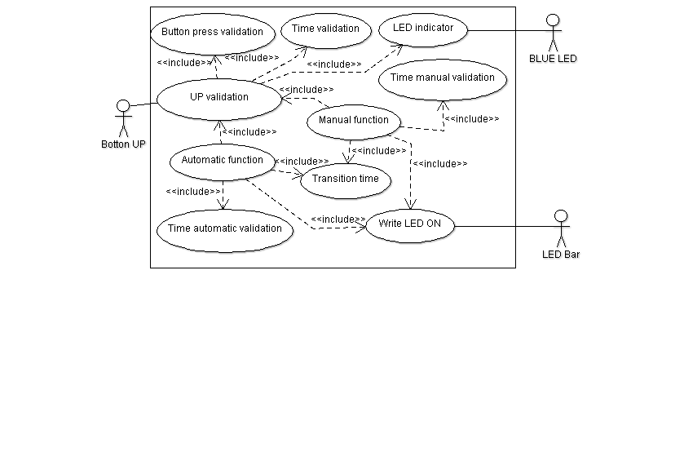
- The time between each transition shall be 400 msec.
- The movement of the window has to be simulated turning on/off the LEDS creating the animation of the window movement.
- In order to consider a validate button press; the button has to be pressed at least 10 msec.
- If a valid UP button is pressed less than 500msecs the window shall UP until get totally CLOSED automatically.
- If a valid UP button is pressed more than 500msecs the window shall UP until get totally CLOSED while the button keep press.

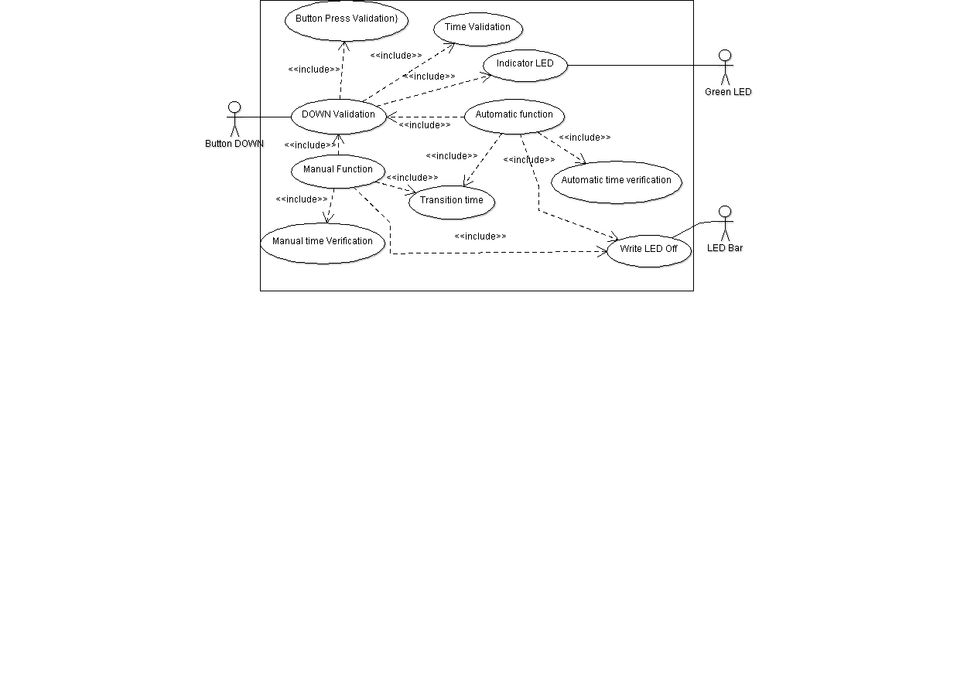
- The time between each transition shall be 400 msec.
- The movement of the window has to be simulated turning on/off the LEDS creating the animation of the window movement.
- In order to consider a validate button press; the button has to be pressed at least 10 msec.
- If a valid DOWN button is pressed less than 500msecs the window shall DOWN until get totally OPEN automatically.
- If a valid DOWN button is pressed more than 500msecs the window shall DOWN until get totally OPEN while the button keep press.

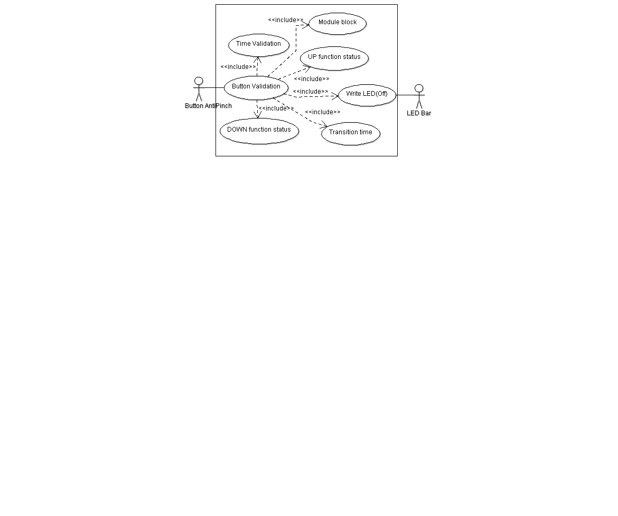
- The signal than indicates to the module the detection of a pinch will be a push button.
- Anti pinch button press has to follow the same characteristics than UP and DOWN buttons for valid press.
- The AntiPinch signal just can be considered as valid when the movement is UP.
- If this signal is valid then the module has to stop the UP Movement and then DOWN the window until the window get totally OPEN.
- After window is totally OPEN the module has to ignore during 5 seconds all button press.

Electric Diagram.

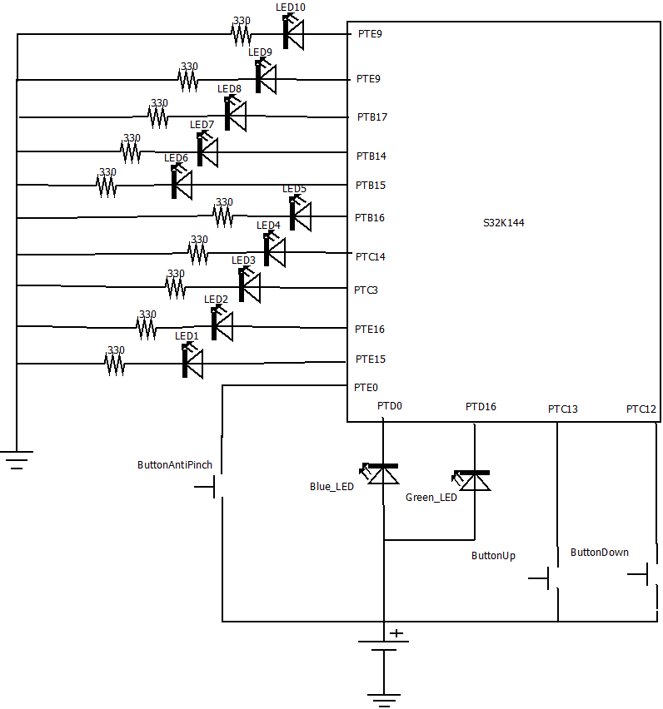

Physical Architecture Diagram.

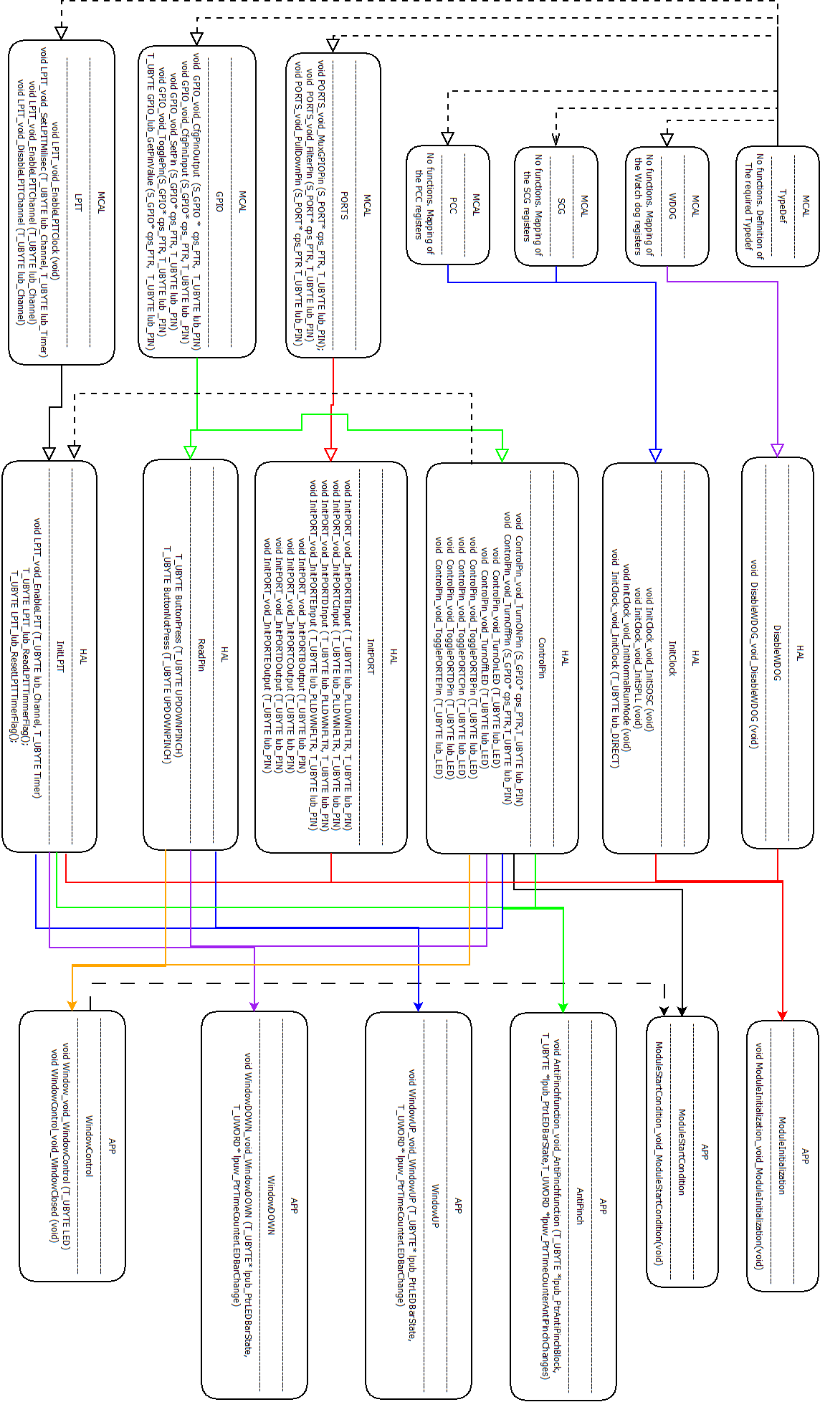

SW Component internal breakdown

Functional Decomposition

Function Description and Dynamic Behavior

Function void GPIO_void_CfgPinOutput (S_GPIO * cps_PTR, T_UBYTE lub_PIN)

Description | Function that writes on the PTR register of the Microcontroller for configurated a Pin as Output.
S GPIO* cps_PTR  input | The S_GPIO structure type store the mapping of the register for writing on the GPIO register descriptions
T_UBYTE lub_PIN  input | Pin number that will be configured as Output . ). It can take values from (0-31)
Return Value | Void
Precondition
Post condition | The Pin is configured as output and can be set for a High(1) or Low(0) with the GPIO_void_SetPin and GPIO_void_ClearPin
Error Conditions

Dynamic Behavior

If the function is not complex a short textual description might be sufficient and a graphical description is not needed.

- The void function receives a pointer to structure of type S_GPIO and a variable lub_PIN. The S_GPIO structure type has mapped the registers of the GPIO configuration of the microcontroller and the lub_PIN variable select the Pin number that wants to be configures as output.
- The function writes a 1 in the PDDR of the selected Pin for configuring it as Output

Function void GPIO_void_CfgPinInput (S_GPIO* cps_ PTR, T_UBYTE lub _PIN)
Description | Function that writes on the PTR register of the Microcontroller for configurated a Pin as Input.
S_GPIO* cps_PTR  input | The S_GPIO structure type store the mapping of the microcontroller for writing on the GPIO register descriptions
T_UBYTE lub_PIN  input | Pin number that will be configured as Output. ). It can take values from (0-31).
Return Value | void
Precondition
Post condition | The Pin is configured as input and can be configured for a having a passive filter and a pull down resistor with the functions PORTS_void_FilterPin and PORTS_void_PullDownPin.
Error Conditions

Dynamic Behavior

- The void function receives a pointer to structure of type S_GPIO and a variable lub_PIN. The S_GPIO structure type has mapped the registers of the GPIO configuration of the microcontroller and the lub_PIN variable select the Pin number that wants to be configures as output.
- The function writes a 0 in the PDDR of the selected Pin for configuring it as Output.

Function void GPIO_void_SetPin (S_GPIO* cps_PTR, T_UBYTE lub _PIN)
Description | Set an output configurated PIN as High (1).
S_GPIO* cps_PTR  input | The S_GPIO structure type store the mapping of the microcontroller for writing on the GPIO register descriptions
T_UBYTE lub PIN  input | Pin number that will be Set as High (1). ). It can take values from (0-31)
Return Value | void
Precondition | The Pin must be configured as Output with the function GPIO_void_CfgPinOutput
Post condition | High(0) value comes out of the Pin
Error Conditions | Set an output Pin

Dynamic Behavior
- The void function receives a pointer to structure of type S_GPIO and a variable lub_PIN. The S_GPIO structure type has mapped the registers of the GPIO configuration of the microcontroller and the lub_PIN variable select the Pin number that wants to be configures as output.
- The function writes a 1 in the PSOR of the selected Pin for setting its output to a High (1) signal..
- Now the output signal of the selected Pin is set at High (1).

Function void GPIO_void_ClearPin(S_GPIO* cps_PTR, T_UBYTE lub _PIN)
Description | Clear an output defined PIN for generating a LOW (0) output signal.
S_GPIO* cps_PTR  Input | The S_GPIO structure type store the mapping of the microcontroller for writing on the GPIO register descriptions.
T_UBYTE lub PIN  Input | Pin number that will be Clear as Low(0). It can take values from (0-31).
Return Value | void
Precondition | The Pin must be configured as Output with the function GPIO_void_CfgPinOutput
Post condition | Low(0) value comes out of the Pin
Error Conditions | Clear an output Pin

Dynamic Behavior
- The void function receives a pointer to structure of type S_GPIO and a variable lub_PIN. The S_GPIO structure type has mapped the registers of the GPIO configuration of the microcontroller and the lub_PIN variable select the Pin number that wants to be configures as output.
- The function writes a 1 in the PCOR of the selected Pin for clearing its output to a Low (0) signal.
- Now the output signal of the selected Pin is clear at Low (0).

Function void GPIO_void_TogglePin(S_GPIO* cps_PTR, T_UBYTE lub _PIN)
Description | Toggle an output defined PIN.
S_GPIO* cps_PTR  Input | The S_GPIO structure type store the mapping of the microcontroller for writing on the GPIO register descriptions.
T_UBYTE lub PIN  Input | Pin number that will be Toggle. It can take values from (0-31).
Return Value | void
Precondition | The Pin must be configured as Output with the function GPIO_void_CfgPinOutput
Post condition | The value that comes out of the Pin will be toggled.
Error Conditions | Use the function in an Input Pin.

Dynamic Behavior
- The void function receives a pointer to structure of type S_GPIO and a variable lub_PIN. The S_GPIO structure type has mapped the registers of the GPIO configuration of the microcontroller and the lub_PIN variable select the Pin number that wants to be configures as output.
- The function writes a 1 in the PTOR of the selected Pin for setting its value to the inverse of its existing logic state.
- Now the output signal of the selected Pin is the inverse signal of the one that it has originally.

Function T_UBYTE GPIO_lub_GetPinValue (S_GPIO* cps_PTR, T_UBYTE lub_PIN)
Description | Get the read value of an input PIN.
S_GPIO* cps_PTR  input | The S_GPIO structure type store the mapping of the microcontroller for writing on the GPIO register descriptions.
T_UBYTE lub PIN  input | Pin number that will be read (0-31).
Return Value | T_UBYTE. High (1) or Low(0)
Precondition | For a valid Output, the Pin that will be read must be defined as input before executing this function.
Post condition | Stored read value of the pin in a variable
Error Conditions | Read an output Pin

Dynamic Behavior
- The T_UBYTE function receives a pointer to structure of type S_GPIO and a variable lub_PIN. The S_GPIO structure type has mapped the registers of the GPIO configuration of the microcontroller and the lub_PIN variable select the Pin number that wants to be configures as output.
- The function reads the value of the PDIR register of the selected Pin for knowing the logic value of the signal that is present on the selected Pin..
- The function returns a High(1) or a Low (0) according to the present signal on the Pin.

Function void PORTS_void_MuxGPIOPins (S_PORT* cps_ PTR, T_UBYTE lub_PIN)
Description | Writes on the Pin Mux Control register (PCR) for setting the mux as Alternative 1 (GPIO)
S_PORT* cps_ PTR  input | The S_PORT structure type store the mapping of the microcontroller for writing on the PORT control and interruptions register descriptions.
T_UBYTE lub_PIN  input | Pin number that will be read (0-31).
Return Value | void
Precondition | It is required to enable the clock for the Peripheral (PORT) first.
Post condition | The functions that configurated GPIOs will be valid.
Error Conditions

Dynamic Behavior
- The void function receives a pointer to structure of type S_PORT and a variable lub_PIN. The S_PORT structure type has mapped the registers of the PORT configuration of the microcontroller and the lub_PIN variable select the Pin number that wants to be configures as output.
- The function goes to the PCR register of the selected Pin and write in the Pin Mux Control register for configuring the pin as GPIO.
- The selected Pin of the function is configured as a GPIO.

Function void PORTS_void_FilterPin (S_PORT* cps_PTR, T_UBYTE lub_PIN)
Description | Activates the Passive Input filter in the corresponding Pin
S_PORT* cps_PTR  input | The S_PORT structure type store the mapping of the microcontroller for writing on the PORT control and interruptions register descriptions.
T_UBYTE lub_PIN  input | Pin number that will be read (0-31).
Return Value | void
Precondition | The Pin where the Passive Filter will be enables must be declared as Input.
Post condition | Noise reduction when reading.
Error Conditions | Configures passive filter for an output pin

Dynamic Behavior
- The void function receives a pointer to structure of type S_PORT and a variable lub_PIN. The S_PORT structure type has mapped the registers of the PORT configuration of the microcontroller and the lub_PIN variable select the Pin number that wants to be configures as output.
- The function goes to the PCR register of the selected Pin and write in the Passive Filter Enable register for enable a passive input filter on the selected Pin.
- The selected Pin of the function has enable a passive filter.

Function void PORTS_void_PullDownPin (S_PORT* cps_PTR T_UBYTE lub_PIN)
Description | Activates the Pull Down register in the corresponding Pin.
S_PORT* cps_PTR  input | The S_PORT structure type stores the mapping of the microcontroller for writing on the PORT control and interruptions register descriptions.
T_UBYTE lub_PIN  input | Pin number that will be read (0-31).
Return Value | void
Precondition | The Pin where the Passive Filter will be enables must be declared as Input.
Post condition | Assuring that the Pin will read a LOW (0) when no High (1) input signal is present in the Pin.
Error Conditions | Configures a Pull Down resistor for an output pin

Dynamic Behavior
- The void function receives a pointer to structure of type S_PORT and a variable lub_PIN. The S_PORT structure type has mapped the registers of the PORT configuration of the microcontroller and the lub_PIN variable select the Pin number that wants to be configures as output.
- The function goes to the PCR register of the selected Pin and write in the Pull Enable register for enable a Pull-Down resistance on the selected Pin.
- The selected Pin of the function has enable a Pull-Down Resistance.

Function void LPIT_void_EnableLPITClock (void)
Description | Enable the clock for the LPIT peripheral.
Parameter | void
Return Value | void
Precondition
Post condition | LPIT pheriphral clock enabled.
Error Conditions

Dynamic Behavior
- The void function is executed..
- The function goes to the MCR register of the LPIT and write in the Module Clock Enable Register for enabling the Peripheral Clock to Timers..
- The Peripheral Clock to Timers is enabled.

Function void LPIT_void_SetLPITMilisec (T_UBYTE lub_Channel, T_UBYTE lub_Timer)
Description | Set the counting of LPIT for a desired number of milliseconds
T_UBYTE lub_Channel  input | Indicate the LPIT channel that is going to be set for the counting of milliseconds.
Return Value | void
Precondition | For it correct counting the SOSC and SPLL should be correctly configured.
Post condition | LPIT working every desired number of milliseconds.
Error Conditions | Milliseconds defined over the capable range of counting for LPIT

Dynamic Behavior
- The void function receives variable lub_Channel for selecting the Channel of the LPIT and a variable lub_Timer for choosing the amount of time in millisecond that the LPIT will spend each cycle.
- The function goes to the TVR register of the selected Channel and writes in the register the equivalent counts needed for the timeout period last the required amount of time.
- The timeout period of the channel timer will last the required time in milliseconds.

Function void LPIT_void_EnableLPITChannel (T_UBYTE lub_Channel)
Description | Enable the desired channel of the LPIT.
T_UBYTE lub_Channel  input | Indicate the LPIT channel that is going to be enabled.
Return Value | void
Precondition | Enable the LPIT peripheral clock.
Post condition | LPIT channel selected enabled.
Error Conditions | Do not enabled the LPIT peripheral clock.

Dynamic Behavior
- The void function receives variable lub_Channel for selecting the Channel of the LPIT that wants to be enabled.
- The function goes to the TCTRL register of the selected Channel and writes in the register Timer Enable for enabling the Timer Channel.
- The Timer Channel is enabled in the selected channel.

Function void LPIT_void_DisableLPITChannel (T_UBYTE lub_Channel)
Description | Disable the desired channel of the LPIT.
T_UBYTE lub_Channel  input | Indicate the LPIT channel that is going to be disabled.
Return Value | void
Precondition | Enable the LPIT peripheral clock.
Post condition | LPIT channel selected disabled.
Error Conditions | Do not enabled the LPIT peripheral clock.

Dynamic Behavior
- The void function receives variable lub_Channel for selecting the Channel of the LPIT that wants to be disabled.
- The function goes to the TCTRL register of the selected Channel and writes in the register Timer Enable for disabling the Timer Channel.
- The Timer Channel is disabled in the selected channel.

Function void InitPORT_void_InitPORTBInput ( T_UBYTE lub_PLLDWNFLTR, T_UBYTE lub_PIN)
Description | Configure a Pin of the PORTB as an Input with the option for adding a Pull Down resistor and a Passive Filter to its characteristics.
T_UBYTE lub_PLLDWNFLTR  Input | Variable for selecting if the Pin will be configured for a Pull Down Resistor or a Passive Filter (FILTER / PULLER).
T_UBYTE lul_PIN  Input | Variable for selecting the Pin number that will configured as Input.
Return Value | void
Precondition | Configuration of the Pin as GPIO
Post condition | Reliable read of signal present in the Pin.
Error Conditions | Configuration non-valid if the Pin is not configured for working as a GPIO.

Dynamic Behavior
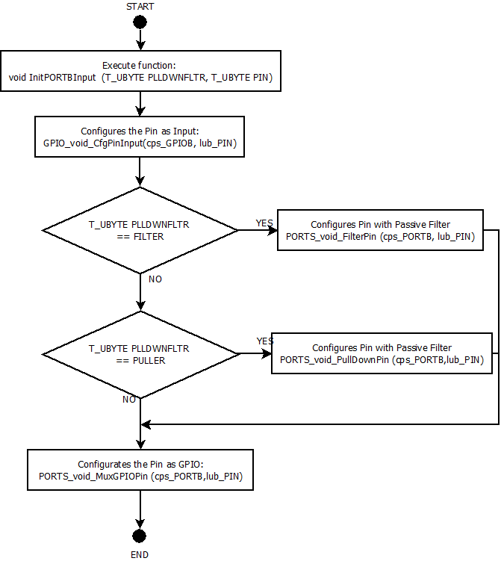

Function void InitPORT_void_InitPORTCInput ( T_UBYTE lub_PLLDWNFLTR, T_UBYTE lub_PIN)
Description | Configure a Pin of the PORTC as an Input with the option for adding a Pull-Down resistor and a Passive Filter to its characteristics.
T_UBYTE lub_PLLDWNFLTR  Input | Variable for selecting if the Pin will be configured for a Pull-Down Resistor or a Passive Filter (FILTER / PULLER).
T_UBYTE lul_PIN  Input | Variable for selecting the Pin number that will configured as Input.
Return Value | void
Precondition | Configuration of the Pin as GPIO
Post condition | Reliable read of signal present in the Pin.
Error Conditions | Configuration non-valid if the Pin is not configured for working as a GPIO.

Dynamic Behavior
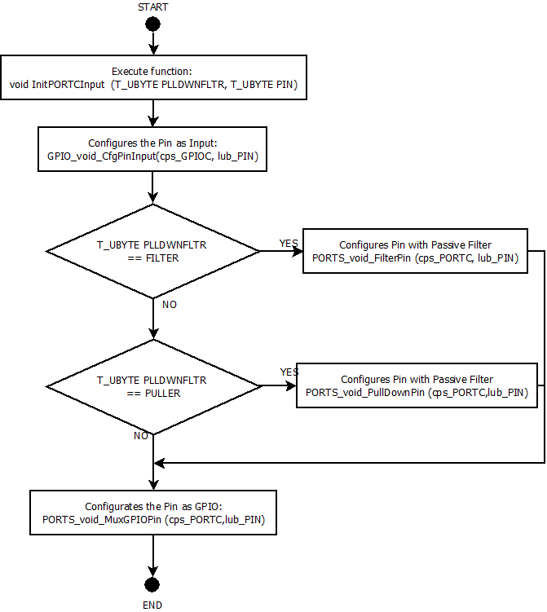

Function void InitPORT_void_InitPORTDInput ( T_UBYTE lub_PLLDWNFLTR, T_UBYTE lub_PIN)
Description | Configure a Pin of the PORTD as an Input with the option for adding a Pull Down resistor and a Passive Filter to its characteristics.
T_UBYTE lub_PLLDWNFLTR  Input | Variable for selecting if the Pin will be configured for a Pull Down Resistor or a Passive Filter (FILTER / PULLER).
T_UBYTE lul_PIN  Input | Variable for selecting the Pin number that will configured as Input.
Return Value | void
Precondition | Configuration of the Pin as GPIO
Post condition | Reliable read of signal present in the Pin.
Error Conditions | Configuration non-valid if the Pin is not configured for working as a GPIO.

Dynamic Behavior
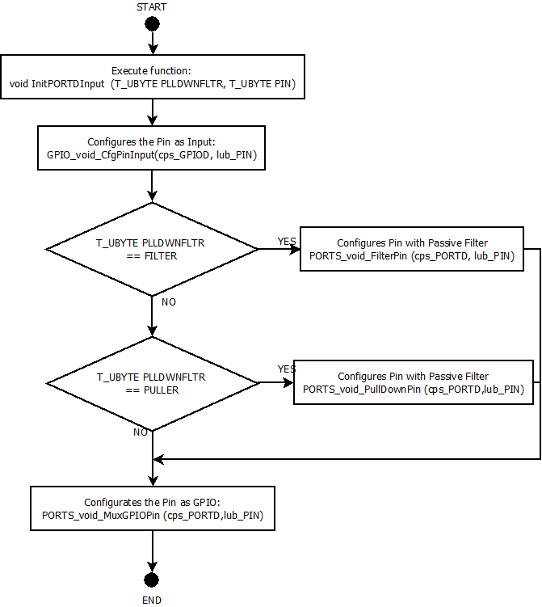

Function void InitPORT_void_InitPORTEInput ( T_UBYTE lub_PLLDWNFLTR, T_UBYTE lub_PIN)
Description | Configure a Pin of the PORTE as an Input with the option for adding a Pull Down resistor and a Passive Filter to its characteristics.
T_UBYTE lub_PLLDWNFLTR  Input | Variable for selecting if the Pin will be configured for a Pull Down Resistor or a Passive Filter (FILTER / PULLER).
T_UBYTE lul_PIN  Input | Variable for selecting the Pin number that will configured as Input.
Return Value | void
Precondition | Configuration of the Pin as GPIO
Post condition | Reliable read of signal present in the Pin.
Error Conditions | Configuration non-valid if the Pin is not configured for working as a GPIO.

Dynamic Behavior

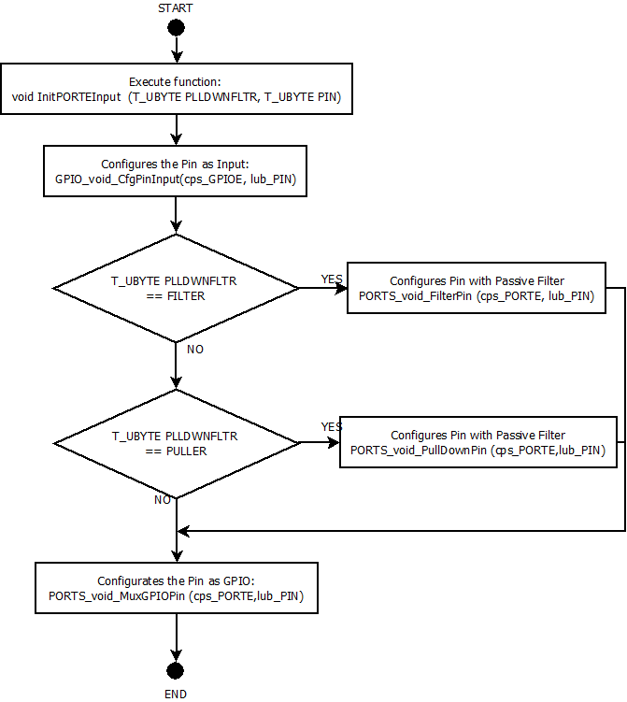

Function void InitPORT_void_InitPORTBOutput (T_UBYTE lub_PIN)
Description | Configure a Pin of the PORTB as an Output.
T_UBYTE lub_PIN  input | Variable for select the Pin that will be configurated as Output.
Return Value | Void
Precondition | Configuration of the Pin as GPIO.
Post condition | Pin capable of delivering High (1) and Low (0) signals.
Error Conditions | Configuration non-valid if the Pin is not configured for working as a GPIO.

Dynamic Behavior
- The void function receives variable lub_PIN for selecting the Pin number of the PORTB that is going to be configured as output.
- The Timer Pin is configured as GPIO and output using the functions GPIO_void_CfgPinOutput (cps_GPIOB, lub_PIN) & GPIO_void_MuxGPIOPin (cps_PORTB, lub_PIN).

Function void InitPORT_void_InitPORTCOutput (T_ULONG lul_PIN)
Description | Configure a Pin of the PORTC as an Output.
T_UBYTE lub_PIN  input | Variable for select the Pin that will be configurated as Output.
Return Value | Void
Precondition | Configuration of the Pin as GPIO.
Post condition | Pin capable of delivering High (1) and Low(0) signals.
Error Conditions | Configuration non-valid if the Pin is not configured for working as a GPIO.

Dynamic Behavior
- The void function receives variable lub_PIN for selecting the Pin number of the PORTC that is going to be configured as output.
- The Timer Pin is configured as GPIO and output using the functions GPIO_void_CfgPinOutput (cps_GPIOC, lub_PIN) & GPIO_void_MuxGPIOPin (cps_PORTC, lub_PIN).

Function void InitPORT_void_InitPORTDOutput (T_ULONG lul_PIN)
Description | Configure a Pin of the PORTD as an Output.
T_UBYTE lub_PIN  input | Variable for select the Pin that will be configurated as Output.
Return Value | Void
Precondition | Configuration of the Pin as GPIO.
Post condition | Pin capable of delivering High (1) and Low(0) signals.
Error Conditions | Configuration non-valid if the Pin is not configured for working as a GPIO.

Dynamic Behavior
- The void function receives variable lub_PIN for selecting the Pin number of the PORTD that is going to be configured as output.
- The Timer Pin is configured as GPIO and output using the functions GPIO_void_CfgPinOutput (cps_GPIOD, lub_PIN) & GPIO_void_MuxGPIOPin (cps_PORTD, lub_PIN).

Function void InitPORT_void_InitPORTEOutput (T_ULONG lul_PIN)
Description | Configure a Pin of the PORTE as an Output.
T_UBYTE lub_PIN  input | Variable for select the Pin that will be configurated as Output.
Return Value | Void
Precondition | Configuration of the Pin as GPIO.
Post condition | Pin capable of delivering High (1) and Low(0) signals.
Error Conditions | Configuration non-valid if the Pin is not configured for working as a GPIO.

Dynamic Behavior
- The void function receives variable lub_PIN for selecting the Pin number of the PORTE that is going to be configured as output.
- The Timer Pin is configured as GPIO and output using the functions GPIO_void_CfgPinOutput (cps_GPIOE, lub_PIN) & GPIO_void_MuxGPIOPin (cps_PORTE, lub_PIN).

Function void InitClock_void_InitSOSC (void)
Description | Configuration of the System Clock Source for working at 8Mhz.
Return Value | Void
Precondition | empty
Post condition | System Clock Source working at 8MHz.
Error Conditions | Empty

Dynamic Behavior
- The void function is executed.
- The System OSC Divide Register (SCG_SOSCDIV) is modified for setting the System OSC clock Divide 2 and System OSC Clock Divide 2 as Divide by 1.
- The system Oscillator Configuration Register (SCG_SOSCCFG) is configured for setting the crystal oscillator for high-gain operation at Medium frequency range.
- Review if the System OSC Control Status Register (SCG_SOSCCSR) is unlocked, so the CSR can be written. If not, waits until it is unlocked.
- Modify the System OSC Control Status Register (SCG_SOSCCSR) for enabling the System OSC.

Function void InitClock_void_InitSPLL (void)
Description | Configures the SPLL for working at 160MHz
Parameter  input | Void
Return Value | Void
Precondition | The SOSC must be configured for working at 8MHz with the function void InitClock_void_InitSOSC (void)
Post condition | SPLL working at 160MHz
Error Conditions | SOSC configurated for different working frequency

Dynamic Behavior
- The void function is executed.
- Review if the Lock Register of the System PLL Control Status Register (SCG_SPLLCSR) is unlocked and the CSR can be written. If not, it waits until it is unlocked.
- Clear the complete System PLL Control Status Register (SCG_SPLLCSR). In this step the System PLL is disabled for prevent glitches to the output divided clock.
- Write on the System PLL Divide Register (SCG_SPLLDIV) for setting the System PLL Clock Divide 1 as divide by 2 and System PLL Clock Divide 2 as divide by 4.
- Write on the System PLL Configuration Register (SCG_SPLLCFG) for setting the System PLL Multiplier with a multiply factor of x40.
- Review if the Lock Register of the System PLL Control Status Register (SCG_SPLLCSR) is unlocked and the CSR can be written. If not, it waits until it is unlocked.
- Writes on the System PLL Control Status Register (SCG_SPLLCSR) for enabling the System PLL.

Function void initClock_void_InitNormalRunMode (void)
Description | Configure the registers in the RCCR (Run Clock Control Register) for setting the Normal Run mode in 80MHz
Parameter  input | void
Return Value | void
Precondition | The SPLL and SOSC must be correctly configured with the functions void InitClock_void_InitSOSC (void) and void InitClock_void_InitSPLL (void).
Post condition | Normal Run mode working at 80MHz.
Error Conditions | Different configuration for the SPLL and SOSC.

Dynamic Behavior
- The void function is executed.
- It is written in the Run Clock Control Register (SCG_RCCR) for configurated the Slow Clock Divide Ratio as Devide-by-3, the Bus Clock Divide Ratio as Devided-by-2, the Core Clock Divide Ratio as Divided-by-2 and selecting the System PLL (SPLL_CLK) as the System Clock Source.
- Review that the System PLL is defined as System Clock Source in the Clock Status Register.

Function void InitClock_void_InitClock (T_UBYTE lub_DIRECT)
Description | Enable clock for the peripherals.
T_UBYTE lub_DIRECT  input | Indicate the peripheral to whom the clock will be enabled.
Return Value | void
Precondition | Peripheral names should match with the one’s in the mapping file PCC.h.
Post condition | Peripheral with clock enabled.
Error Conditions | Misspell in peripheral names.

Dynamic Behavior
- The void function receives a lub_DIRECT variable that indicates the peripheral where the clock is going to be enabled. When the clock is enabled, the current clock section and divider options are locked.
- It is write in the Clock Gate Control of the PCC for enable the clock in the peripheral.

Function void ControlPin_void_TurnONPin (S_GPIO* cps_PTR,T_UBYTE lub_PIN)
Description | Set the Output of a Pin as High(1). The LEDs of the Bar turn on with a High(1) signal.
S_GPIO* cps_PTR  input | Pointer to the structure that has mapped the register for change the output of the Pin.
T_UBYTE lub PIN  input | Value of the Pin to whom output will be set as High(1).
Return Value | void
Precondition | Configuration of the PORT and Pin for working as GPIO output.  The LEDs of the bar have been mapped for the function to work.
Post condition | Output signal of the Pin will be a High (1).
Error Conditions | Apply the function to a Pin configured as input.

Dynamic Behavior
- The void function receives the variable cps_PTR for pointing to the desired PORT in the GPIO mapped registers and the variable lub_PIN for selecting the Pin number that will be Turned On.
- The function GPIO_void_SetPin (S_GPIO* cps_PTR, T_UBYTE lub _PIN) uses the requested variables of the function for setting the output of the Pin as High (1).

Function void ControlPin_void_TurnOffPin (S_GPIO* cps_PTR,T_UBYTE lub_PIN)
Description | Clear the Output of a Pin as Low(0). The LEDs of the Bar turn off with a Low(0) signal.
S_GPIO* cps_PTR  input | Pointer to the structure that has mapped the register for change the output of the Pin.
T_UBYTE lub PIN  input | Value of the Pin to whom output will be set as Low (0).
Return Value | Void
Precondition | Configuration of the PORT and Pin for working as GPIO output.  The LEDs of the bar have been mapped for the function to work.
Post condition | Output signal of the Pin will be a Low (0).
Error Conditions | Apply the function to a Pin configured as input.

Dynamic Behavior
- The void function receives the variable cps_PTR for pointing to the desired PORT in the GPIO mapped registers and the variable lub_PIN for selecting the Pin number that will be Turned On.
- The function . GPIO_void_ClearPin (S_GPIO* cps_PTR, T_UBYTE lub _PIN) uses the requested variables of the function for cleaning the output of the Pin as Low (0).

Function void ControlPin_void_TurnOnLED (T_UBYTE lub_LED)
Description | Set the Output of a Pin as Low(0). The movement indicator LEDs turn on with a Low(0) signal.
T_UBYTE lub LED  input | LED (BlueLED & GreenLED )to whom output will be set as Low(0).
Return Value | void
Precondition | Configuration of the PORT and Pin for working as GPIO output.  BlueLED and GreenLED values have been mapped .
Post condition | Output signal of the Pin will be a Low (0).
Error Conditions | Apply the function to a Pin that do not has a movement indicator LED connected.

Dynamic Behavior
- The void function receives the variable lub_LED for selecting one of the two movement indicator LED (BlueLED & GreenLED).
- The function GPIO_void_ClearPin (S_GPIO* cps_PTR, T_UBYTE lub _PIN) is called for clearing the output of the Pin as Low (0). It is good to mention that the movement indicators LED are turned on with a Low(0) value and turned on with a High (1) value.

Function void ControlPin_void_TurnOffLED (T_UBYTE lub_LED)
Description | Set the Output of a Pin as High(1). The movement indicator LEDs turn on with a High(1) signal.
T_UBYTE lub LED  input | LED (BlueLED & GreenLED )to whom output will be set as High(1).
Return Value | void
Precondition | Configuration of the PORT and Pin for working as GPIO output.  BlueLED and GreenLED values have been mapped .
Post condition | Output signal of the Pin will be a High(1).
Error Conditions | Apply the function to a Pin that do not has a movement indicator LED connected.

Dynamic Behavior
- The void function receives the variable lub_LED for selecting one of the two movement indicator LED (BlueLED & GreenLED).
- The function GPIO_void_SetPin (S_GPIO* cps_PTR, T_UBYTE lub _PIN) is called for setting the output of the Pin as High (1). It is good to mention that the LED are turned on with a Low(0) value and turned on with a High (1) value.

Function void ControlPin_void_TogglePORTBPin (T_UBYTE lub_LED)
Description | Toggle the output signal of a Pin in the PORTB.
T_UBYTE lub LED  input | Pin to whom output will be toggled.
Return Value | Void
Precondition | Configuration of the PORT and Pin for working as GPIO output.
Post condition | Output signal of the Pin will be toggled
Error Conditions | Apply the function to a Pin that is not declared as output.

Dynamic Behavior
- The void function receives the variable lub_LED for selecting one of the Pins of the PORTB.
- The function void GPIO_void_TogglePin(S_GPIO* cps_PTR, T_UBYTE lub_PIN)is called for toggling the output of the selected Pin of the PORTB.
- The output of the Pin is toggled.

Function void ControlPin_void_TogglePORTCPin (T_UBYTE lub_LED)
Description | Toggle the output signal of a Pin in the PORTC.
T_UBYTE lub LED  input | Pin to whom output will be toggled.
Return Value | Void
Precondition | Configuration of the PORT and Pin for working as GPIO output.
Post condition | Output signal of the Pin will be toggled
Error Conditions | Apply the function to a Pin that is not declared as output.

Dynamic Behavior
- The void function receives the variable lub_LED for selecting one of the Pins of the PORTC.
- The function void GPIO_void_TogglePin(S_GPIO* cps_PTR, T_UBYTE lub_PIN)is called for toggling the output of the selected Pin of the PORTC.
- The output of the Pin is toggled.

Function void ControlPin_void_TogglePORTDPin (T_UBYTE lub_LED)
Description | Toggle the output signal of a Pin in the PORTD.
T_UBYTE lub LED  input | Pin to whom output will be toggled.
Return Value | Void
Precondition | Configuration of the PORT and Pin for working as GPIO output.
Post condition | Output signal of the Pin will be toggled
Error Conditions | Apply the function to a Pin that is not declared as output.

Dynamic Behavior
- The void function receives the variable lub_LED for selecting one of the Pins of the PORTD.
- The function void GPIO_void_TogglePin(S_GPIO* cps_PTR, T_UBYTE lub_PIN)is called for toggling the output of the selected Pin of the PORTD.
- The output of the Pin is toggled.

Function void ControlPin_void_TogglePORTEPin (T_UBYTE lub_LED)
Description | Toggle the output signal of a Pin in the PORTE.
T_UBYTE lub LED  input | Pin to whom output will be toggled.
Return Value | Void
Precondition | Configuration of the PORT and Pin for working as GPIO output.
Post condition | Output signal of the Pin will be toggled
Error Conditions | Apply the function to a Pin that is not declared as output.

Dynamic Behavior
- The void function receives the variable lub_LED for selecting one of the Pins of the PORTD.
- The function void GPIO_void_TogglePin(S_GPIO* cps_PTR, T_UBYTE lub_PIN)is called for toggling the output of the selected Pin of the PORTD.
- The output of the Pin is toggled.

Function void DisableWDOG_void_DisableWDOG (void)
Description | Disable the WDOG.
Precondition  input | Void
Return Value | Void
Precondition
Post condition | WDOG will be disabled
Error Conditions

Dynamic Behavior
- The void function is executed.
- It is written in the Watchdog Counter Register (CNT) the unlock sequence 0xD928C520u.
- It is written in the Watchdog Timeout Value Register (TOVAL) the maximum possible value for TOVALHIGH and TOVALLOW.
- Write on the Watchdog Control and Status Register(CS) for selecting the LPO clock as the Watchdog clock and the enabling the support for 32-bit refresh/unlock command write words.

Function void InitLPIT_void_EnableLPIT (T_UBYTE lub_Channel, T_UBYTE lub_Timer)
Description | Enable an LPIT channel and its time in milliseconds per cycle.
T_UBYTE lub_Channel  input | LPIT channel that is going to be enabled.
T_UBYTE_Timer  input | Time per cycle in the LPIT.
Return Value | Void
Precondition | Correct initialization of NormalRunMode and T_UBYTE Timer do not exceed count limit of the LPIT.
Post condition | The selected channel of the LPIT’s cycle last the time defined
Error Conditions | Defined a time per cycle that exceeds the capabilities of the LPIT.  Incorrect initialization of NormalRunMode.

Dynamic Behavior
- The function received the variable lub_Channel for selecting the LPIT channel that will be Enabled and a lub_Timer that will indicate the amount of time that the timer is going count in milliseconds.
- it is written in the Peripheral Clock Controller (PCC), at the LPIT register for selected the Peripheral Clock Source (PCS) in the Clock Option 6.
  - Function void InitLPIT_void_ReadLPITTimerFlag (void)
Description | Read the Timer Flag for detect when it had elapsed.
Parameter  input | void
Return Value | Void
Precondition | Correct initialization of the LPIT.
Post condition | It will return a High (1) value while the timer counter hasn’t elapsed. When it elapsed it will return a Low(0).
Error Conditions | Incorrect initialization of the LPIT.

Dynamic Behavior
- The function executes.
- The FlagState variable in the code is Cleared to Low(0) value.
- The LPIT Flag is read. If it is read as Low(0), the value of the FlagState is set to High(1).
- The FlagState variable is returned as result to the function.
  - Function void InitLPIT_void_ResetLPITTimerFlag (void)
Description | Reset the Timer Flag of the LPIT.
Parameter  input | void
Return Value | Void
Precondition | Correct initialization of the LPIT.
Post condition | The overflow Flag of the LPIT is reset.
Error Conditions | Incorrect initialization of the LPIT.

Dynamic Behavior
- The function executes.
- It is written in the register of the LPIT for reset the overflow flag.
- The LPIT overflow flag is reset.

Function T_UBYTE ReadPin_lub_ButtonPress (T_UBYTE lub_UDP)
Description | Check if a button is pressed.
T_UBYTE lub_UDP  input | The possible values for this variable are : UP , DOWN & PINCH. This variable allows the user to choice between the three buttons of the module (ButtonUp, ButtonDown & ButtonAntiPinch) for reading its state.
Return Value | The function returns a High (1) if the chosen button is pressed or a Low(0) if the button is not pressed.
Precondition | The Pins to whom the buttons are connected must be declared as input with Pull-Down resistor and Passive filter.
Post condition | There will be a variable with a logic value that represent the state of the chosen button.
Error Conditions | Incorrect configuration of the Pins connected to the Buttons.

Dynamic Behavior
- The function receives the variable T_UBYTE lub_UDP that defines which one of the buttons is going to be read.
- If the ButtonUp is selected, the function T_UBYTE GPIO_lub_GetPinValue (S_GPIO* cps_PTR, T_UBYTE lub_PIN) will be executed for reading the state of the Pin where the button is connected. If a High signal is read, the function will return a 1; if a Low signal is read the function will return a 0.
- If the ButtonDown is selected, the function T_UBYTE GPIO_lub_GetPinValue (S_GPIO* cps_PTR, T_UBYTE lub_PIN) will be executed for reading the state of the Pin where the button is connected. If a High signal is read ,the function will return a 1; if a Low signal is read ,the function will return a 0.
- If the ButtonAntiPinch is selected, the function T_UBYTE GPIO_lub_GetPinValue (S_GPIO* cps_PTR, T_UBYTE lub_PIN) will be executed for reading the state of the Pin where the button is connected. If a High signal is read the function will return a 1; if a Low signal is read the function will return a 0.

Function T_UBYTE ReadPin_lub_ButtonNotPress (T_UBYTE lub_UDP)
Description | Check if a button is not pressed.
T_UBYTE lub_UDP  input | The possible values for this variable are : UP , DOWN & PINCH. This variable allows the user to choice between the three buttons of the module (ButtonUp, ButtonDown & ButtonAntiPinch) for reading its state.
Return Value | The function returns a High (1) if the chosen button is not pressed or a Low(0) if the button is pressed.
Precondition | The Pins to whom the buttons are connected must be declared as input with Pull-Down resistor and Passive filter.
Post condition | There will be a variable with a logic value that represent the state of the chosen button.
Error Conditions | Incorrect configuration of the Pins connected to the Buttons.

Dynamic Behavior
- The function receives the variable T_UBYTE lub_UDP that defines which one of the buttons is going to be read.
- If the ButtonUp is selected, the function T_UBYTE GPIO_lub_GetPinValue (S_GPIO* cps_PTR, T_UBYTE lub_PIN) will be executed for reading the state of the Pin where the button is connected. If a Low signal is read, the function will return a 1; if a High signal is read the function will return a 0.
- If the ButtonDown is selected, the function T_UBYTE GPIO_lub_GetPinValue (S_GPIO* cps_PTR, T_UBYTE lub_PIN) will be executed for reading the state of the Pin where the button is connected. If a Low signal is read ,the function will return a 1; if a High signal is read ,the function will return a 0.
- If the ButtonAntiPinch is selected, the function T_UBYTE GPIO_lub_GetPinValue (S_GPIO* cps_PTR, T_UBYTE lub_PIN) will be executed for reading the state of the Pin where the button is connected. If a Low signal is read the function will return a 1; if a High signal is read the function will return a 0.

Function void ManualMovement_void_ManualMovement ( T_UBYTE lub_Button)
Description | Validate if press of either ButtonUp or ButtonDown last the required time for activate the Manual movement.
T_UBYTE lub_Button  input | The possible values for this variable are: UP or DOWN. This variable indicates to which button is going to be applied function.
Return Value | void
Precondition | The Pins to whom the buttons are connected must be declared as input with Pull-Down resistor and Passive filter. The Pins at whom the LED movement indicators must be configured as output.
Post condition | If the button push is valid, the simulate for the Manual Movement will start Turning on and off the corresponding Led movement indicators.
Error Conditions | Incorrect configuration of the Pins connected to the Buttons and LED movement indicators.

Dynamic Behavior

Function void WindowControl_void_WindowControl ( T_UBYTE lub_LED)
Description | Turn on and off each one of the LEDs in the LED bar for creating the simulation of the Window’s Crystal movement.
T_UBYTE lub_LED  input | There are 10 possible values for this variable: from LED10 to LED1. These values represent each LED in the LED Bar.
Return Value | void
Precondition | The Pins to whom the LEDs are connected must be declared as output.
Post condition | The LED bar will turn on and off its components according to the simulation requirements.
Error Conditions | Incorrect configuration of the Pins connected to the LEDs.

Dynamic Behavior

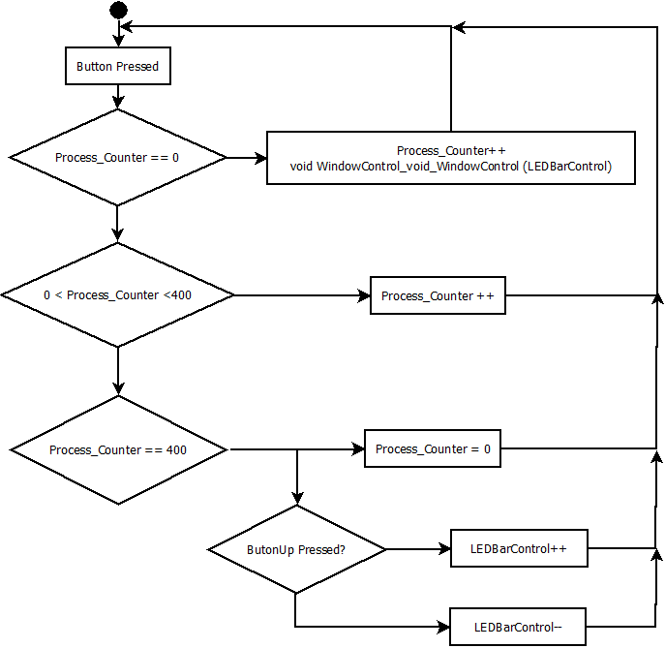

Function void WindowControl_void_WindowClosed ( void)
Description | Turn on all the LED in the LED Bar for simulate that the window is completely closed. This function is used for initializing the emulation of the window.
Parameter  input | void
Return Value | void
Precondition | The Pins to whom the LEDs are connected must be declared as output.
Post condition | The LED bar will have all the LED’s turned on.
Error Conditions | Incorrect configuration of the Pins connected to the LEDs.

Dynamic Behavior
- The function is executed. It is an initialization of the emulation function.
- Use the functions ControlPin_void_TogglePORTBPin (T_UBYTE lub_LED), ControlPin_void_TogglePORTCPin (T_UBYTE lub_LED), ControlPin_void_TogglePORTDPin (T_UBYTE lub_LED) and ControlPin_void_TogglePORTEPin (T_UBYTE lub_LED) for turning on all the LEDs in the LED bar and start the simulation with the window completely closed.
  - Function void ModuleInitialization_void_ModuleInitialization ( void)
Description | This function disables the WatchDog, initializes the clock for the pheriperals, initializes the SOSC, initializes the SPLL, initialize the NormalRunMode, enables the LPIT, initializes the Pins.
Parameter  input | void
Return Value | void
Precondition | void
Post condition | The module is configured and the peripheries initialized.
Error Conditions

Dynamic Behavior
- The function disables the WatchDog with the function DisableWDOG_void_DisableWDOG(void).
- Initializes the pheriperials PORTB,PORTC,PORTD,PORTE with the function InitClock_void_InitClock (T_UBYTE lub_DIRECT)
- Initializes the SOSC, SPLL and NormalRunMode with the functions InitClock_void_InitSOSC() , InitClock_void_InitSPLL (),initClock_void_InitNormalRunMode().
- Enable the LPIT module with the InitLPIT_void_EnableLPIT(T_UBYTE lub_Channel, T_UBYTE lub_Timer).
- Initializes the Pins as input or outputs with the functions InitPORT_void_InitPORTInput ( T_UBYTE lub_PLLDWNFLTR, T_UBYTE lub_PIN) and void InitPORT_void_InitPORTOutput (T_UBYTE lub_PIN).
  - ( void)

  - Function void ModuleStartConditions_void_ModuleStartConditions ( void)
Description | This function Set the start conditions in the LED bar and the LED movement indicators (BlueLED and GreenLED)
Precondition | Correct initialization of the Pins that have connected a LED as Output.
Post condition | The LED bar starts completely turned on and the movement indicators LED are turned off.
Error Conditions | Incorrect initialization of the Pins that have connected a LED as Output.
- The function is executed.
- Each one of the LEDs in the LED Bar is turned on.
- BlueLED and GreenLED are turned off.

  - Function void WindowUP_void_WindowUP ( T_UBYTE* lpub_PtrLEDBarState, T_UWORD* lpuw_PtrTimeCounterLEDBarChange)
Description | This function emulate the upward movement of the Window’s Crystal.
T_UBYTE* lpub_PtrLEDBarState  input | Pointer to the global variable that stores the state of the LED bar that is emulating the Window’s Crystal position.
T_UWORD* lpuw_PtrTimeCounterLEDBarChange  input | Pointer to the global variable that is counting the 400msec that should elapse for change between state (Turn on/off LED) of the LED Bar that is emulating the Window’s Crystal position.
Return Value | void
Precondition | Global variables and module timers and ports shall be initialized correctly.
Post condition | The module will emulate an upward movement of the Window’s Crystal when a valid input signal combination triggers it.
Error Conditions | Incorrect initialization of the module or the global variables.

Dynamic Behavior

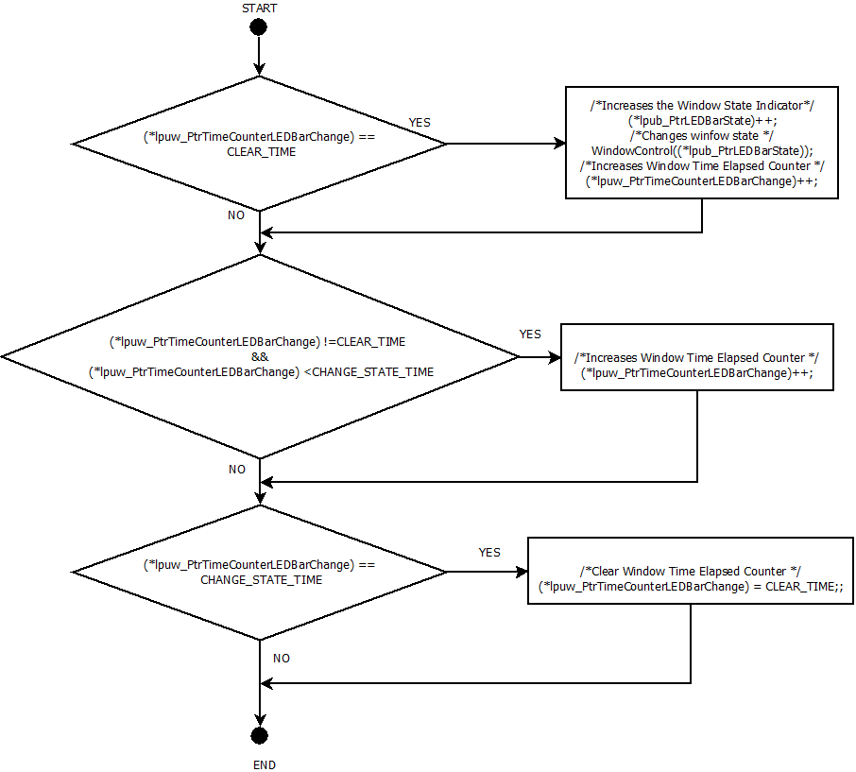

  - Function void WindowDOWN_void_WindowDOWN ( T_UBYTE* lpub_PtrLEDBarState, T_UWORD* lpuw_PtrTimeCounterLEDBarChange)
Description | This function emulate the downward movement of the Window’s Crystal.
T_UBYTE* lpub_PtrLEDBarState  input | Pointer to the global variable that stores the state of the LED bar that is emulating the Window’s Crystal position.
T_UWORD* lpuw_PtrTimeCounterLEDBarChange  input | Pointer to the global variable that is counting the 400msec that should elapse for change between state (Turn on/off LED) of the LED Bar that is emulating the Window’s Crystal position.
Return Value | void
Precondition | Global variables and module timers and ports shall be initialized correctly.
Post condition | The module will emulate a downward movement of the Window’s Crystal when a valid input signal combination triggers it.
Error Conditions | Incorrect initialization of the module or the global variables.

Dynamic Behavior

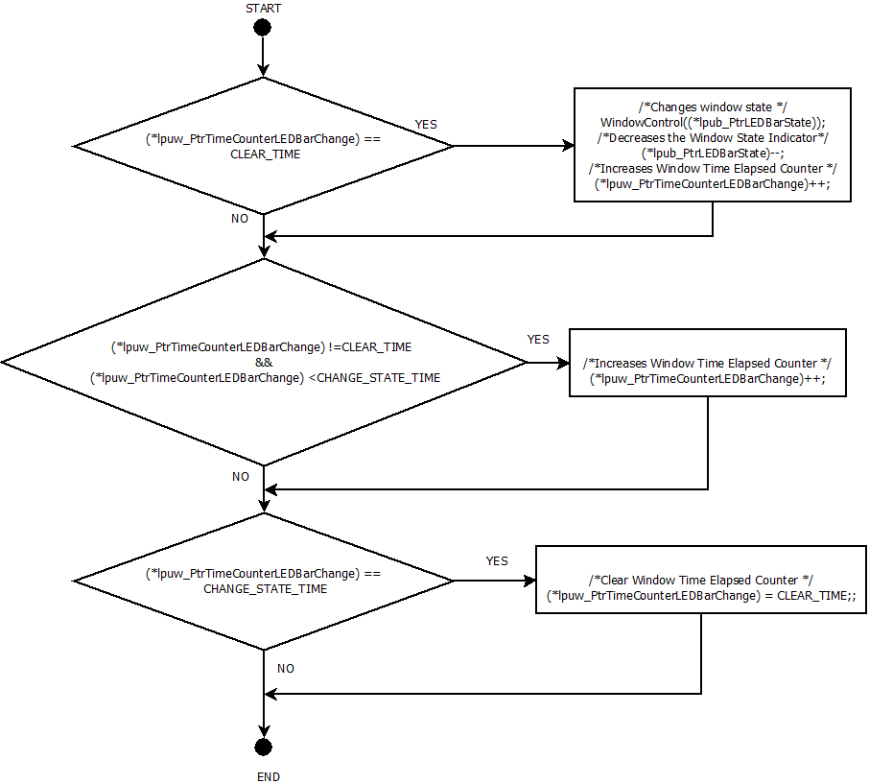

  - Function void AntiPinch_void_AntiPinchfunction ( T_UBYTE* lpub_PtrAntiPinchBlock,T_UBYTE* lpub_PtrLEDBarState, T_UWORD* lpuw_PtrTimeCounterAntiPinchChanges)
Description | This function emulates the action of the AntiPinch function
T_UBYTE* lpub_ PtrAntiPinchBlock  input | Pointer to the global variable Flag that is turned on when a the AntiPinch function is activated.
T_UBYTE* lpub_PtrLEDBarState  input | Pointer to the global variable that stores the state of the LED bar that is emulating the Window’s Crystal position.
T_UWORD* lpuw_ PtrTimeCounterAntiPinchChanges  input | Pointer to the global variable that is counting the time elapsed during the AntiPinch execution for activating the corresponding chronological tasks.
Return Value | void
Precondition | Global variables and module timers and ports shall be initialized correctly. A valid combination of conditions must be presented for activating the AntiPinch.
Post condition | The module will emulate the AntiPinch function and come back to its normal function when finished.
Error Conditions | Incorrect initialization of the module or the global variables.

Dynamic Behavior

